**MOBILE APPLICATION DEVELOPMENT (MAD)**

**CEP – 22SW**

Names: Sarwat Aijaz, Tayyaba Bhatti

Roll no: 22SW024, 22SW051

Section: 03

Submitted to: Ma’am Mariam Memon

**Real World Problem Identification**

In today’s fast-paced lifestyle, people often struggle to find convenient ways to book salon appointments. Most salons still rely on manual booking systems such as phone calls or walk-ins, which leads to several challenges:

* **Time wastage:** Customers have to wait for their turn or call multiple times to check availability.
* **Scheduling conflicts:** Without a proper digital system, double bookings or missed appointments are common.
* **Limited accessibility:** Customers cannot view available slots, services, or pricing without physically visiting the salon.
* **Lack of reminders:** Customers often forget about upcoming appointments due to no reminder system.

Similarly, salon owners face difficulties managing multiple appointments, tracking clients, and updating service availability. Hence, there is a need for a **centralized digital platform** that allows both users and salon owners to manage appointments easily and efficiently.

**Proposed Solution**

To address these challenges, the “**Salon Appointment App”** has been developed as a **cross-platform mobile application** using **Flutter**. It allows customers to **book salon appointments online** and enables salon owners to **manage their bookings, services, and schedules** in real time.

* User registration and login via email and password.
* Browse nearby salons.
* View available services and stylists.
* Book or cancel appointments.
* Manage booking history.

**Responsive User Interfaces (Screenshots of your app on different screens & platforms)**

**Android Devices:**

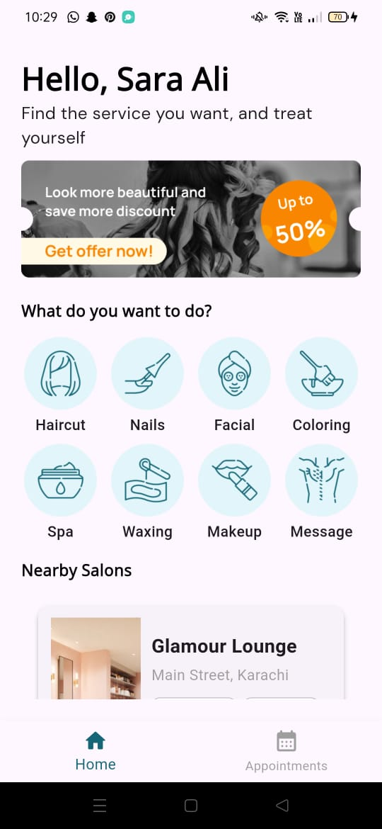

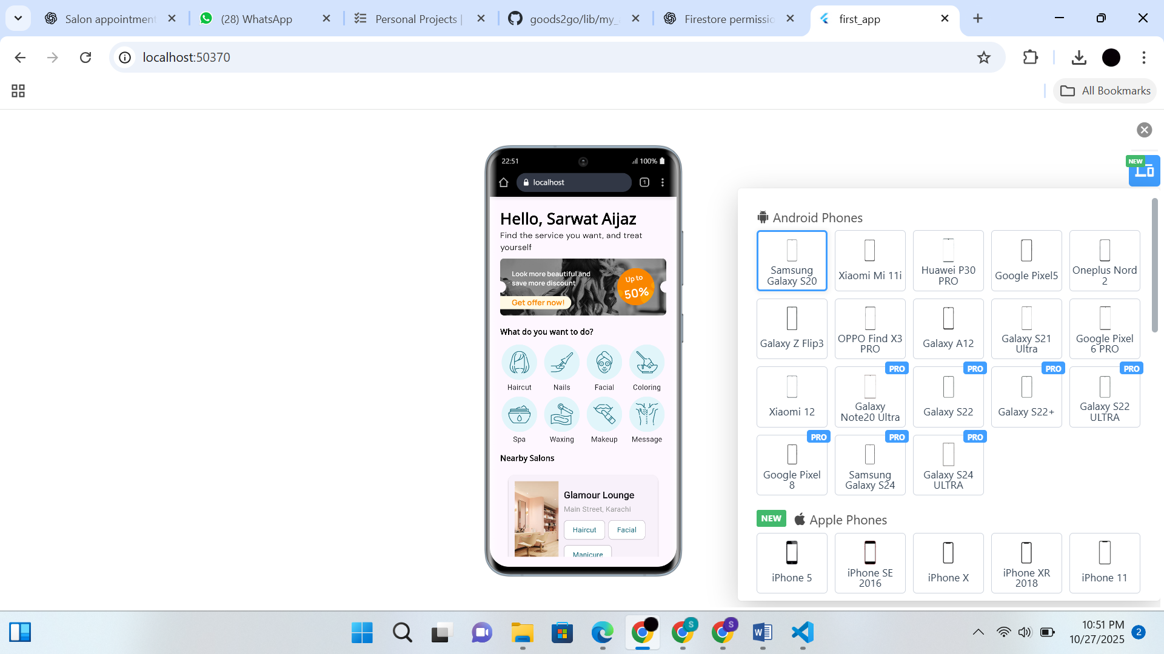

**iOS Devices:**

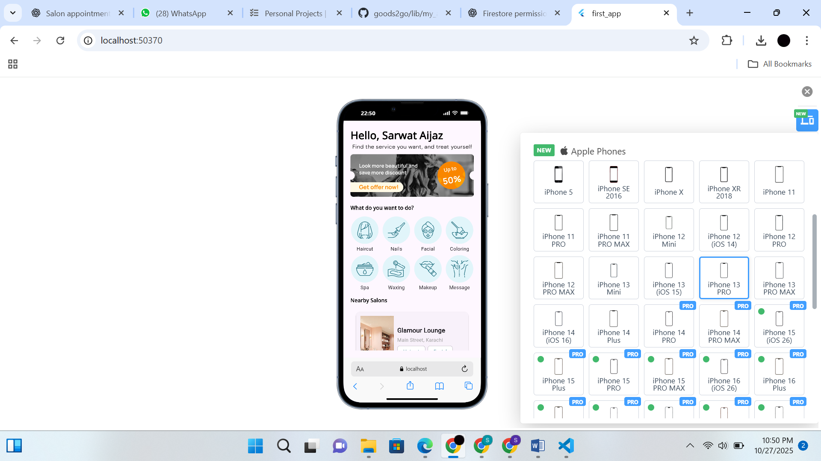

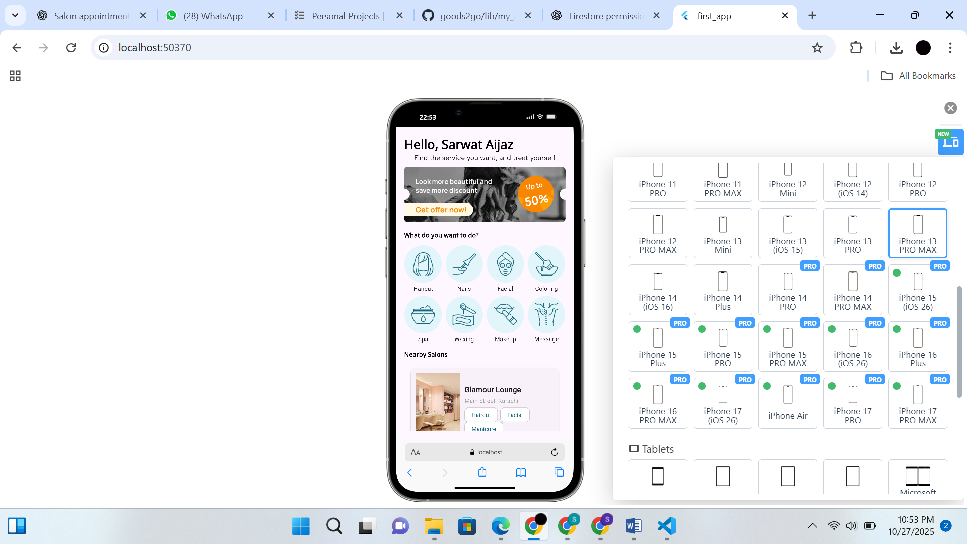

**Data Storage**

The **Salon Appointment App** uses **Firebase Firestore** as its primary database. It works seamlessly with Flutter for Android and iOS, ensuring uniform functionality across all devices.

**Justification:** Firebase Firestore is an ideal choice for the Salon Appointment App because it provides real-time synchronization across devices while also supporting offline access. Even though some data, like user-specific appointments or preferences, is personal, storing it in Firestore ensures that it remains consistent, secure, and backed up in the cloud. Users can access their appointments seamlessly across multiple devices, and changes are automatically updated without conflicts. Firestore’s SDK for Flutter provides smooth integration and easy CRUD operations for developers.

**Packages used**

**Google Fonts Package:**  
Used to easily apply a wide variety of fonts in the app, enhancing UI/UX and maintaining consistent typography across all devices.

**Issues and Bugs Encountered and Resolved during Development**

**Android NDK and minSdkVersion Mismatch:**

Project’s build failed because the **NDK version** and **minimum SDK version** in the Flutter app are lower than what Firebase plugins require.  
Specifically the minSdkVersion is set to **21**, which was resolved after setting it to 23.

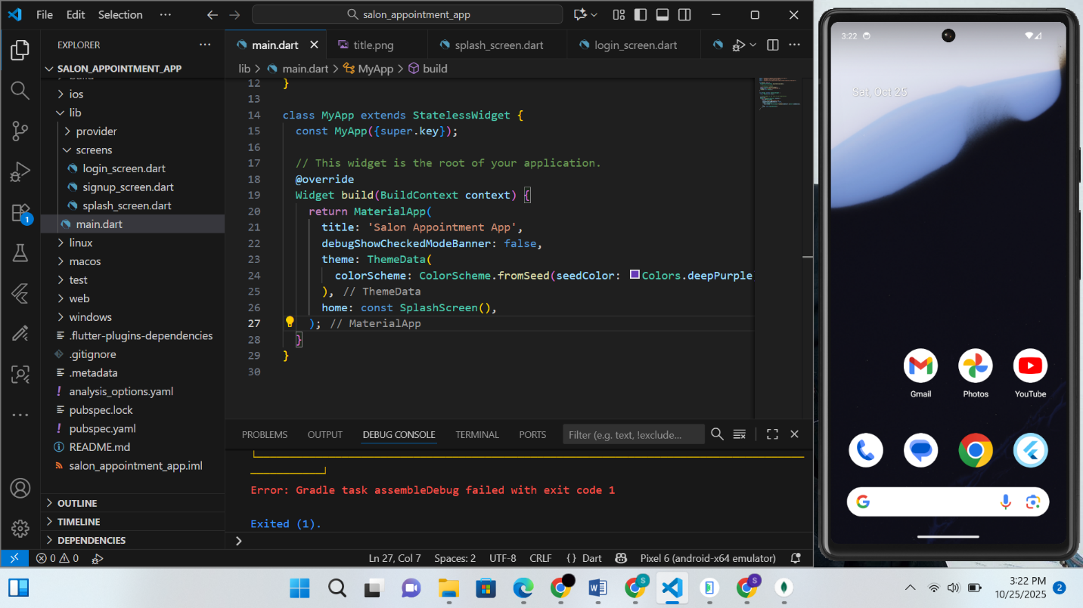

|  |
| --- |
|  |

|  |
| --- |
|  |

**Error: "HomeScreen not defined":**

Flutter is unable to recognize the HomeScreen widget even though it is already defined in the project. This issue occurred due to outdated or corrupted build caches from previous compilations and was fixed with hot restart.

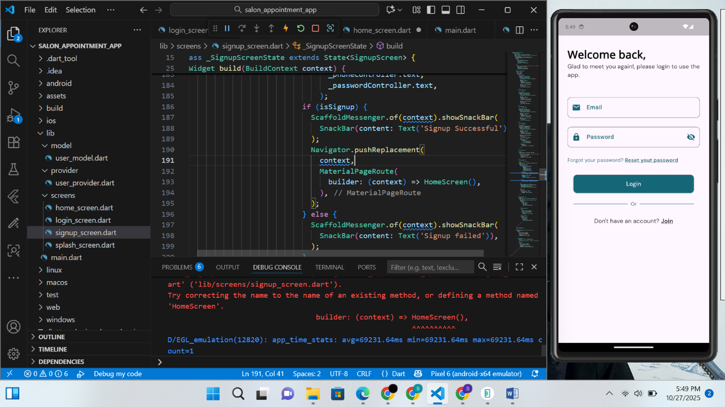

**Error: Firestore Permission Denied:**

This error occurred when the app attempted to read or write data in **Firebase Firestore** without the required permissions by default that was fixed after setting the permissions to allow users to read and write to database.

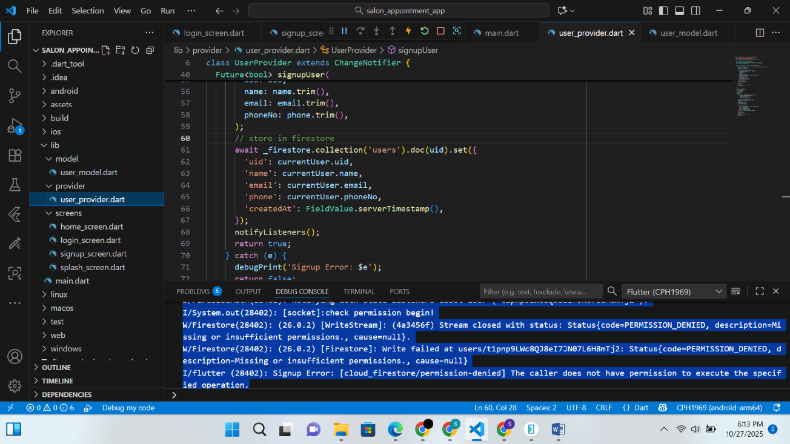

**GridView has no bounded height:**

This error happened because your GridView **has no bounded height** so Flutter doesn’t know how much space it can take. It was resolved after wrapping it in Expanded widget.

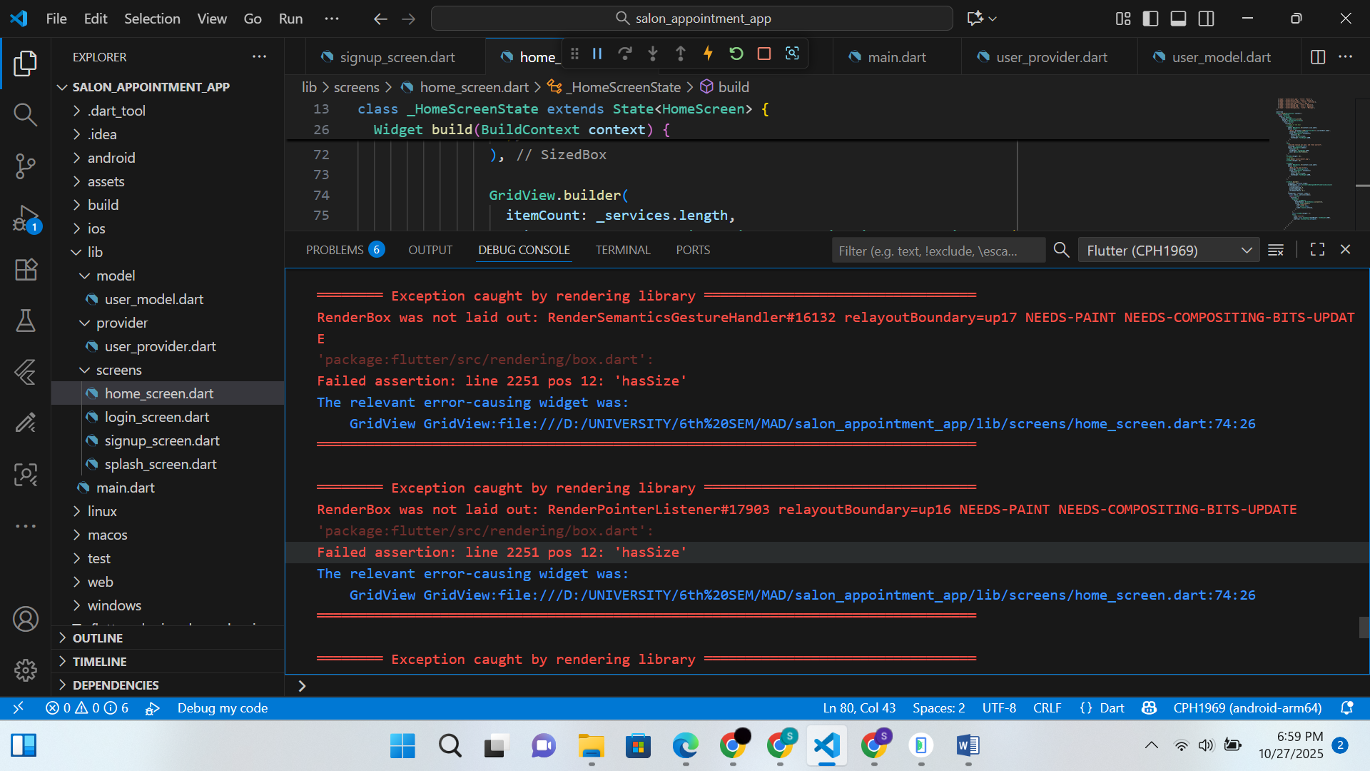

**ListView.builder is inside another scrollable widget:**

The crash (RenderBox was not laid out) is happening because the ListView.builder is **inside another scrollable widget** (SingleChildScrollView) **without constraints**. This was resolved after removing SingleChildScrollView.

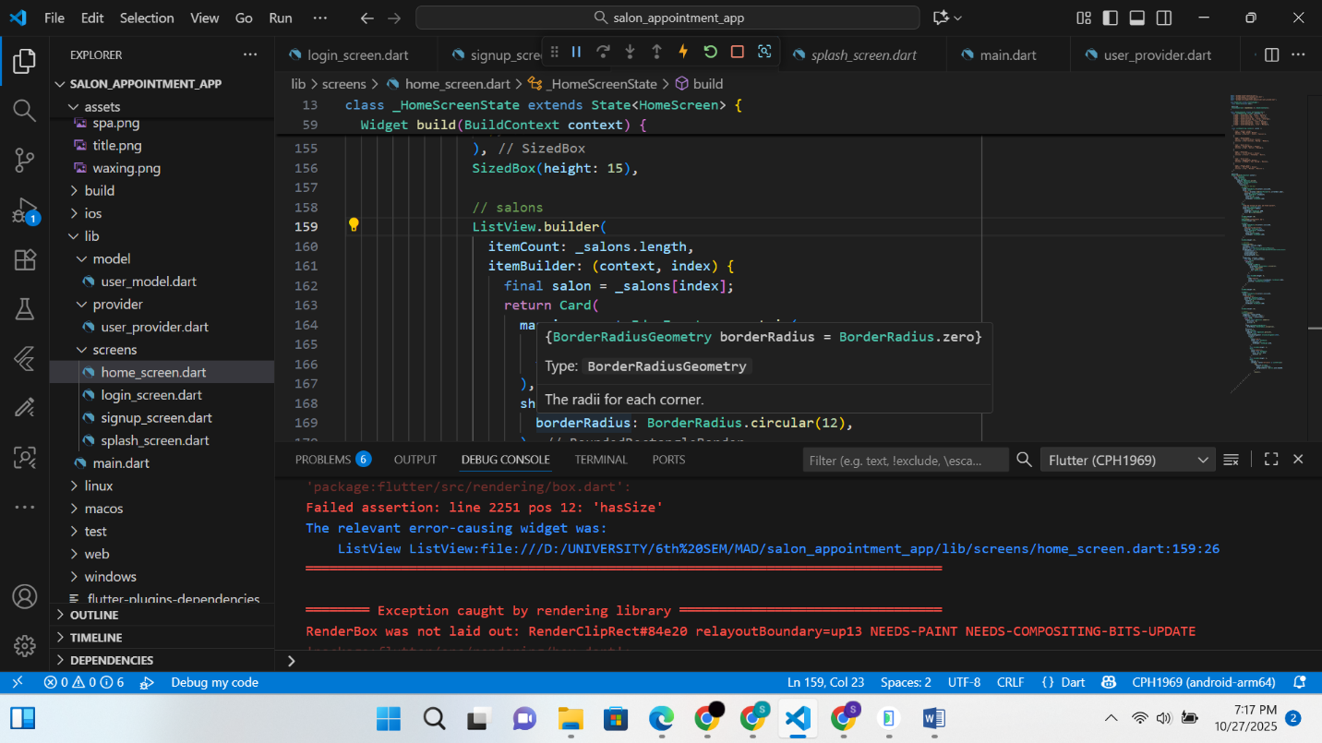

**Renderflex overflowed:**

That **“RenderFlex overflowed on the right”** error because Row’s children are too wide to fit on the screen horizontally. This was resolved after wrapping the widget with Expanded widget.

**‘**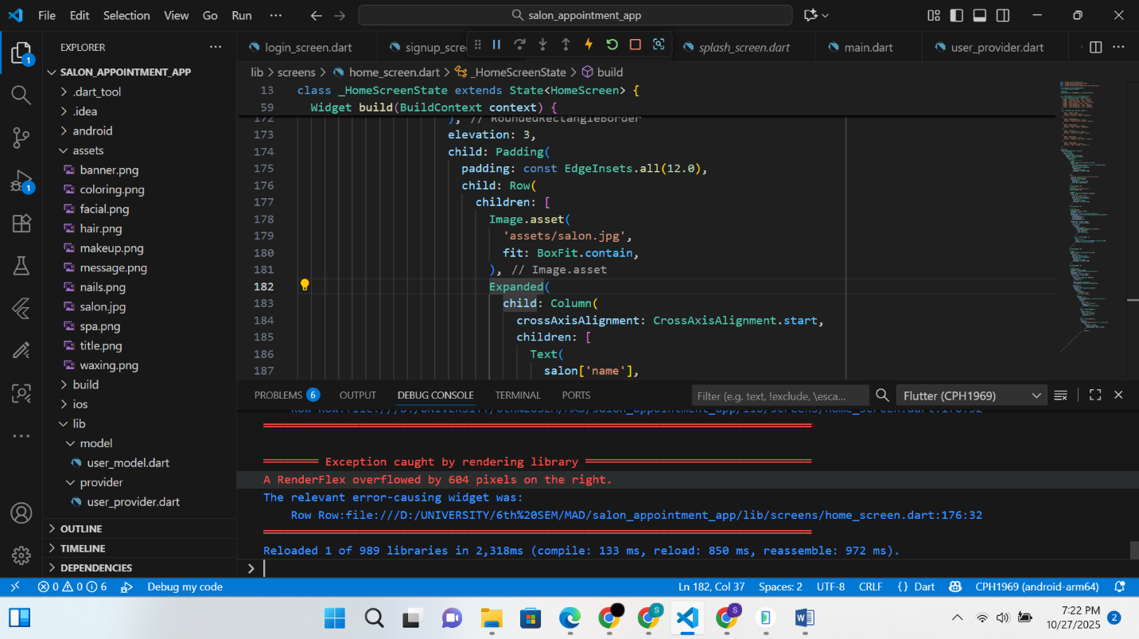

**Error: "SalonServiceMenu not defined":**

Flutter is unable to recognize the SalonServiceMenu widget even though it is already defined in the project. This issue occurred due to outdated or corrupted build caches from previous compilations which was fixed after hot restart.

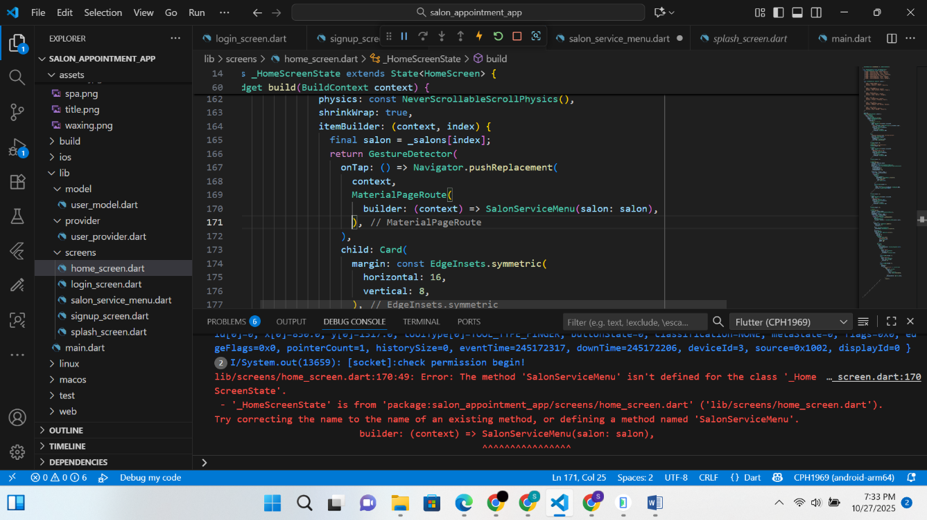

**Type “null” is not a subtype of type “String”:**

Happened because Flutter is still running with **a hot-reload session** that has **old widget trees or provider states** referencing a previous version of the model (before adding imageAsset as required) which was fixed with hot restart.

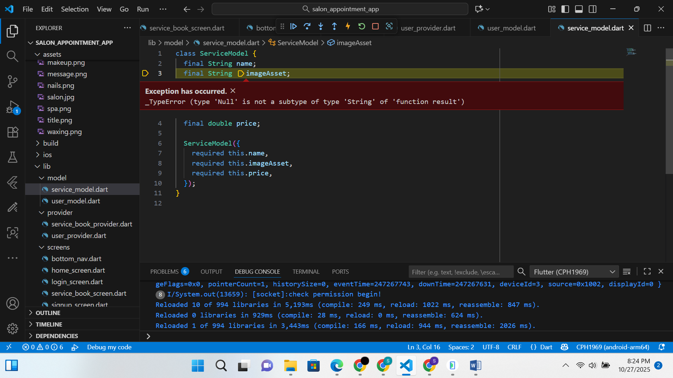

**Boxconstraints provide “infinite width”:**

This error happened when container inside a Row **tried to take infinite width** because its parent (Row) doesn’t provide bounded constraints. This was fixed after wrapping it with SizedBox widget.

